CURRICLUM VITA

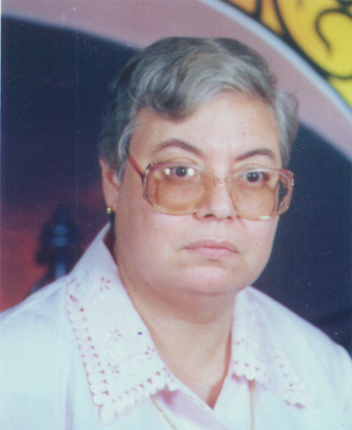

Dr. Suzanne Azmy MESHREKY – DAOUD

Departments of Mathematics - Assiut University , Assiut 71516 , EGYPT

E - mail : drsuzanned1@yahoo. com
Tel. Office (002-088) ( 2411386 –2137) Tel. Home:(002-088) 2314194
Fax: (002-088)2342708 Telx: 92863 Assiut Un.

Name : Suzanne Azmy Meshreky – DAOUD

Position : Emeritus Professor Of Mathematics.

Date of Birth : 28-2-1948
Place of Birth : Assiut –Egypt.
Sex : Female.
Marital Status : Married.
Nationality : Egyptian.
Mailing address : Departments of Mathematics .Faculty of Sciences
Assiut University , Assiut 71516 , EGYPT.

Academic Background :
Ph.D. (Pure Mathematics) (Several complex analysis) Poiters – France (1985).
B.Sc. (Special Mathematics) Assiut University –Egypt (1969).

Professional Experiences (Occupation) :

Demonstrator: Departments of Mathematics. Faculty of Sciences Assiut University
4/9/1969 .

Lecturer of Mathematics : Departments of Mathematics. Faculty of Sciences Assiut University 9/11/1986 .

Assoc. Prof. Of Mathematics : Departments of Mathematics. Faculty of Sciences Assiut University 27/6/ 1993 .

Emeritus Associated Professor: Departments of Mathematics. Faculty of Sciences Assiut University 28/2/2008.
Emeritus Professor: Departments of Mathematics. Faculty of Sciences Assiut University 1/8/2008.

Scientific Activities : General Specialization : Several Complex Analysis.

Scientific Prizes : Prize of the Best paper in Math. Faculty of Sciences Assiut University (1993).

Scientific Experiences :
- Supervisor of student at M.SC Degree .
- Assessment of papers submitted to some international Journals(Portugal & India) .
- Concerning to published paper, look to the of publications.
Supervisions :
1- Mahmoud Tawfiq Mohammed Abdel-Nabi, Sets of Polynomials in Different Regions. , M. Sc, 17 January 1996
Supervisors : Kamel Ahmed Mohamed Sayed, Suzanne Azmi Meshreky , Mohammed Saleh Metwali

List of Publications

By
Dr. Suzanne Meshreky – DAOUD

Departments of Mathematics. Faculty of Sciences Assiut University

E - mail : drsuzanned1@yahoo. Com

1- S.DAOUD: Entire functions represented by Dirichlet series of two complex variables. Port. Math. 43(1985-1986) 407-415.
2- S.DAOUD: Bases in the space of Entire Dirichlet functions of two complex variables. Coll. Math. Vol. 35 (1984) 35-42.
3- S.DAOUD: Ordre d’une fonction de Dirichlet entiere de plusieurs variables complexes. Port. Math. Vol.43 (1985-1986) 271-284.
4- S.DAOUD: On the class of Entire Dirichlet functions of several complex variables having finite order point. Port. Math. Vol. 43(1985-1986) 417-427.
5-S.DAOUD: Ordres des functions entieres definies par des series de Dirichlet de deux variables complex (II) Riv. Mat. Univ. Parama (4) 12 (1986) 283-288.
6- S.DAOUD: Some class of integral functions represented by Dirichlet series of several complex variables having finite order. Coll. Math. Vol. 36(1985) 13-26.
7- S.DAOUD: On the mean values of an Entire function represented by Dirichlet series of several complex variables. Coll. Math. Vol. (1985) 243-252.
8- S.DAOUD: On the space of integral Dirichlet functions of several complex variables. Port. Math. Vol. 44(1987) 333-340.
9- S.DAOUD: On the class of integral functions represented by Dirichlet series of several complex variables having finite growth. Port. Math. Vol. 46(1989) 219-224.
10- S.DAOUD: Entire functions represented by Dirichlet series of two complex variables. Proc. Of Assiut first intern. Conf. (1990) 87-93.
11- S.DAOUD: Bases in the space of Entire functions of several complex variables represented by Dirichlet series having finite order point. Jour. Of the Indian Math. Soc. Vol. 54(1989) 133-138.
12- S.DAOUD: On the convergent of the series . Bull. Fac. Sci. Assiut Univ. 20(1-C)(1991)1-12.
13- S.DAOUD: On the class of Entire functions defined by Dirichlet series of several complex variables. Jour. Of Math. Analysis &Applications. Vol. 162 (1991) 294-299.
14- S.DAOUD: Space of Entire functions represented by Dirichlet series of several complex variables having finite growth. Jour. of Math. And Comp. Sci. Vol. 4 No.3(1991) 305-313 .
15- S.DAOUD: Certain Operators in the space of Entire functions represented by Dirichlet series of several complex variables. Le Matematiche Vol. XLVII (1992) 3-8.
16- S.DAOUD: Characteristics of the Growth of an Integral function represented by Dirichlet series of several complex variables. Rivista di Mathematics pure-Ed-Applicata 1994 (129-141).

